**Prerequisistes:**

1. Install Docker Desktop in your computer.

**Get Started**

Follow this steps in order to start with your testing Airflow environment in docker:

1. The first step is to download Docker Desktop from the [official website](https://www.docker.com/products/docker-desktop). For this article, I installed 4.4.4 version.
2. After installing Docker Desktop, we need to download a docker-compose.yaml file that you can also find [here](https://airflow.apache.org/docs/apache-airflow/2.0.2/docker-compose.yaml).
3. Now that we have both files, we need to create our airflow directory. Go to the following path: C:/Users/<your_user>/. Inside of that directory, create a folder called docker and inside of docker create another folder called airflow.
4. Now that we have our airflow folder, we must do the following: a)Create three folders called dags, plugins and logs respectively; b) Move our YAML to that directory.

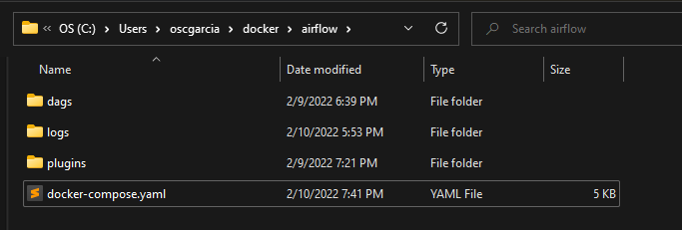

Your directory will look like this

5. Now we are ready to start our instance of Airflow in docker. We need to open a PowerShell window and go to the directory above.

6. Then, we need to run the following commands:

*docker-compose up airflow-init*

*docker-compose up*

Note: After second command, a window will keep running some code. We can close this window without any problem.

7. After that, we can go to our Docker Desktop app and we will see that a container named airflow was created inside section Containers/Apps. This container will have 7 sub-containers inside.

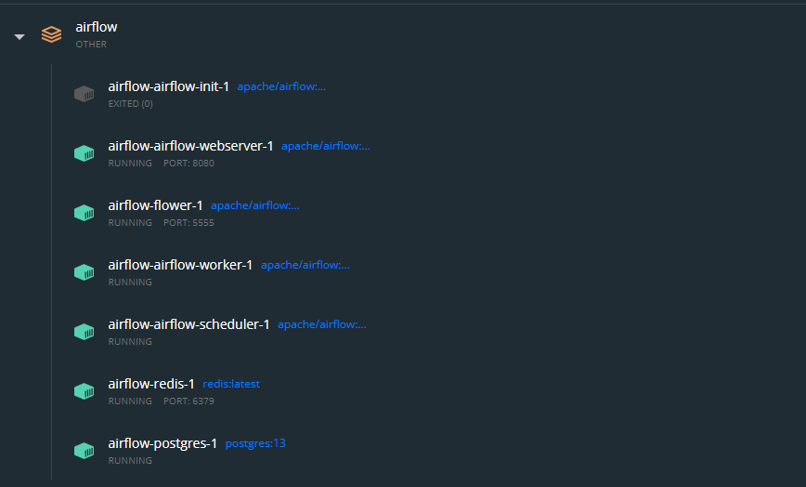

Your container will look like this

8. With this, we have our Apache Airflow instance completely ready to start developing our DAGS.

9. Go to localhost:8080, login with user “airflow” and password “airflow” and start coding.

Note: You can put all your DAGs in the dags folder and all your plugins in plugins folder both created in step 4.